**Configure and enable Inter VLAN communication with router assistance.**

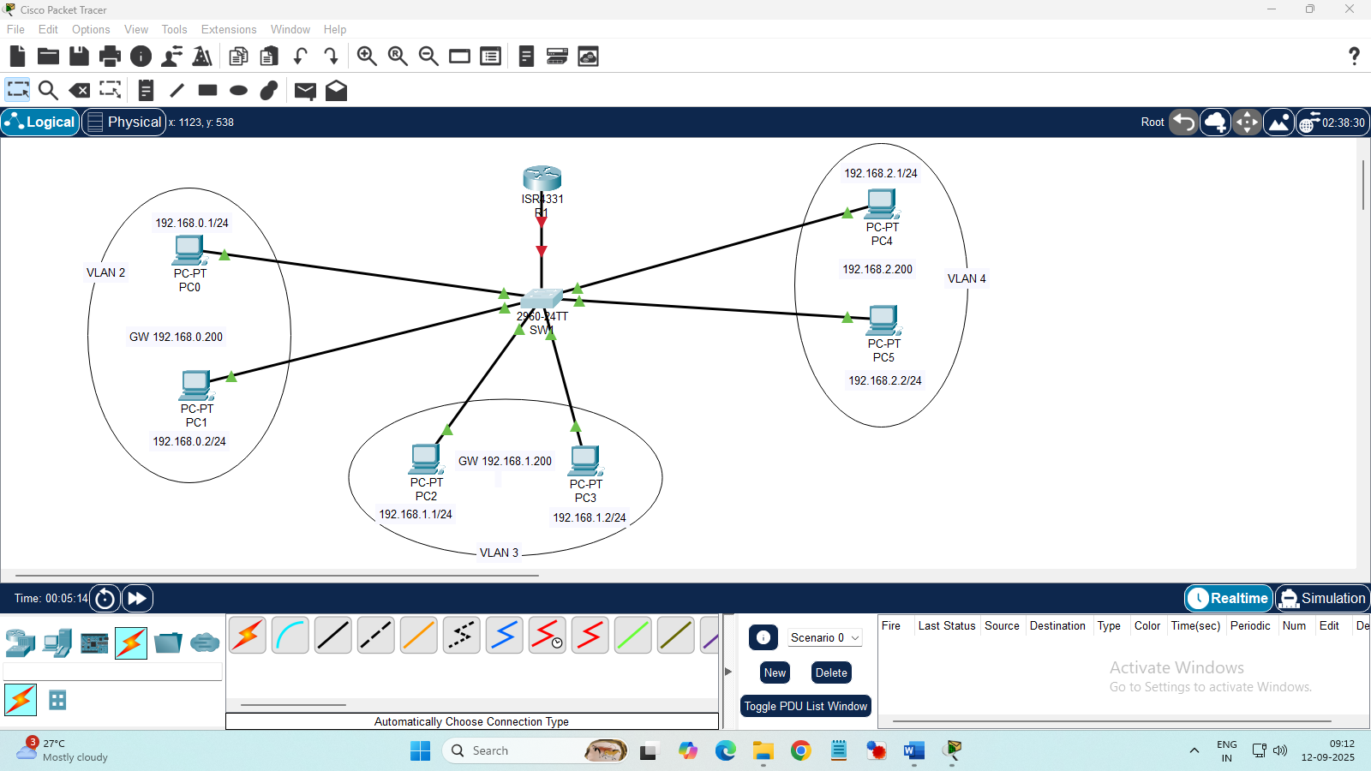

Aim: To Configure and enable inter VLAN communication with router assistance.

Algorithm:

Step 1: Start the process

Step 2: Open Cisco packet tracer and place network devices and connect them as per requirement.

Step 3: Configure IP address on all PCs.

Step 4: Create VLANs and assign switchport access and trunk for the interfaces in the switch.

Step 5: Create Sub-interfaces in the router and configure IEEE 802.1q using the command encapsulation dot1 q and then configure IP address for the sub-interfaces

Step 6: Verify the connections by pinging all other PCs from any PC and show ip route and arp table.

Step 7: Stop the process.

**Switch**

>en

#conf t

#hostname SW1

#do sh vlan br

#vlan 2

#vlan 3

#vlan 4

#exit

#int range f0/2-3

#switchport access vlan 2

#int range f0/4-5

#switchport access vlan 3

#int range f0/6-7

#switchport access vlan 4

#exit

#int f0/1

#switchport mode trunk

**Router**

>en

#conf t

#hostname R1

#do sh ip int br

#int g0/0/0.2

#encapsulation dot1Q 2

#ip address 192.168.0.200 255.255.255.0

#int g0/0/0.3

#encapsulation dot1Q 3

#ip address 192.168.1.200 255.255.255.0

#int g0/0/0.4

#encapsulation dot1Q 4

#ip address 192.168.2.200 255.255.255.0

#int g0/0/0

#no sh

#end

#wr

**Router checking commands**

sh ip route

sh arp

**from PC Cmd**

Ping All PC IP…

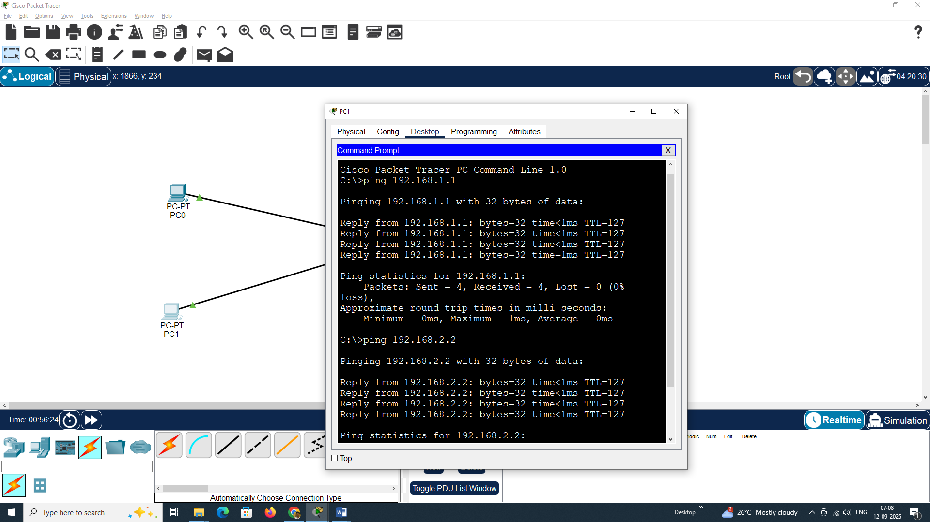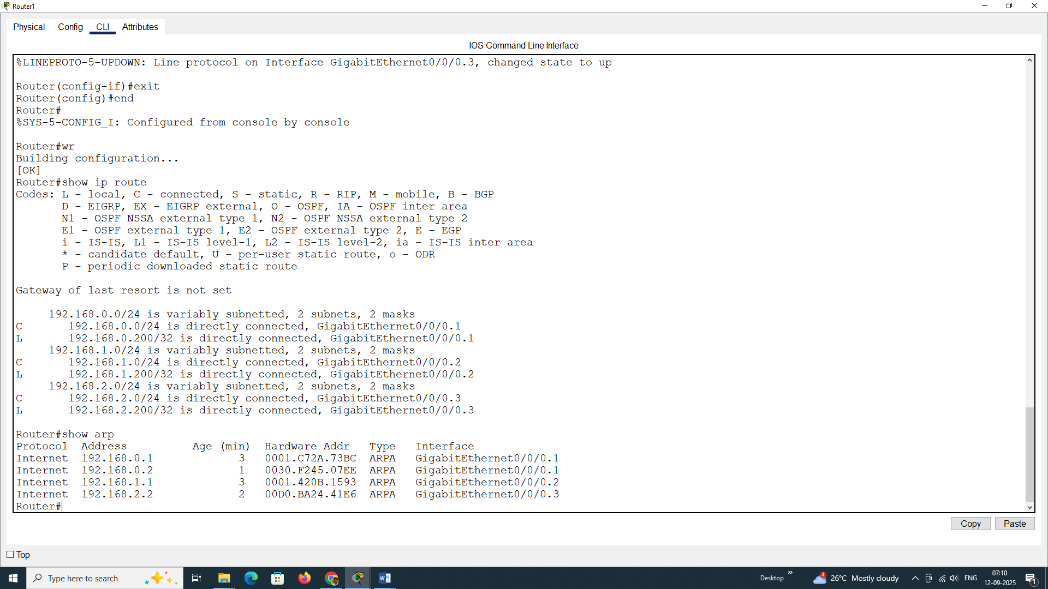

8. Enable Inter-VLAN configuration via Layer3 switch configuration.

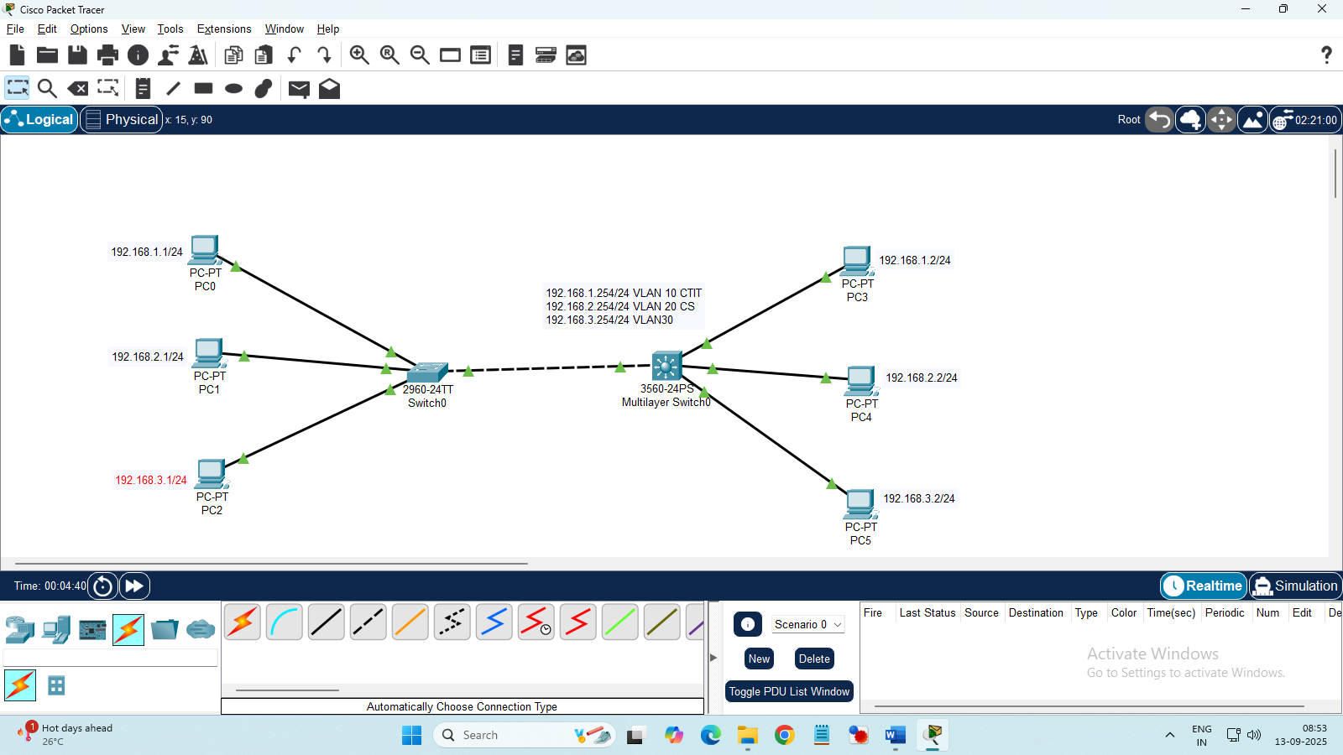

Aim: To enable Inter-VLAN configuration via Layer3 switch configuration.

Algorithm:

Step 1: Start the process

Step 2: Open Cisco packet tracer and place network devices and connect them as per requirement.

Step 3: Configure IP address on all PCs.

Step 4: Create VLANs and assign switchport access and trunk for the interfaces in the switch.

Step 5: Create VLAN and configure switchport trunk encapsulation dot1 q and then configure the trunk port in the multilayer switch.

Step 6: Configure IP address for the VLANs in the multilayer switch and enable ip routing

Step 6: Verify the connections by pinging all other PCs from any PC.

Step 7: Stop the process.

**Switch 1**

>en

#conf t

#hostname SW1

#int f0/1

#switchport mode trunk

#exit

#vlan 10

#name CTIT

#exit

#vlan 20

#name CS

#exit

#vlan 30

#name BCA

#exit

#int f0/2

#switchport access vlan 10

#exit

#int f0/3

#switchport access vlan 20

#exit

#int f0/4

#switchport access vlan 30

#exit

#wr

Multilayer Switch:

Switch>

>en

#conf t

#hostname MLSW1

#int f0/1

#switchport trunk encapsulation dot1q

#switchport mode trunk

#exit

#vlan 10

#name CTIT

#exit

#vlan 20

#name CS

#exit

#vlan 30

#name BCA

#exit

#int f0/2

#switchport access vlan 10

#exit

#int f0/3

#switchport access vlan 20

#exit

#int f0/4

#switchport access vlan 30

#exit

#int vlan 10

#ip add 192.168.1.254 255.255.255.0

#no shut

#exit

#int vlan 20

#ip add 192.168.2.254 255.255.255.0

#no shut

#exit

#int vlan 30

#ip add 192.168.3.254 255.255.255.0

#no shut

#exit

#end

#ip routing

#wr

